Name: Majid Ali
CMS ID: 053-25-0017
Course: Java (Lab: 12)
Task 1:
interface Measurable {
double area();
}
class Rectangle implements Measurable {

private double width;
private double length;

public Rectangle(double width, double length){
this.width = width;
this.length = length;
}
@Override
public double area(){
return width * length;
}

public double perimeter(){
return 2 * (width + length);
}
}

public class Main {
public static void main(String[] args){

Measurable m = new Rectangle(4.0, 5.0);
System.out.println("Area: " + m.area());

Rectangle r = (Rectangle) m;
System.out.println("Perimeter: " + r.perimeter());
}
}
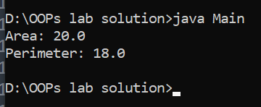
Task 2:
interface Payable {
double amountDue();
}

class HourlyService implements Payable {

private double hours;
private double ratePerHour;

public HourlyService(double hours, double ratePerHour){
this.hours = hours;
this.ratePerHour = ratePerHour;
}

@Override
public double amountDue(){
return hours * ratePerHour;
}
}

public class CheckInterfaces {
public static void main(String[] args){

Payable p = new HourlyService(10, 50);
System.out.println("Amount Due: " + p.amountDue());
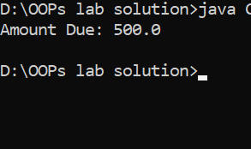
}
}

Task 3:
interface Describable {
String describe();
}

class Product implements Describable {

private String sku;
private String name;

public Product(String sku, String name) {
this.sku = sku;
this.name = name;
}

@Override
public String describe(){
return "Product: " + name + " (" + sku + ")";
}
}

public class InterfaceMain {
public static void main(String[] args) {

Describable d = new Product("SKU-001", "Mooseman");
System.out.println(d.describe());
}
}
